Information on tourist spots around Ojiya

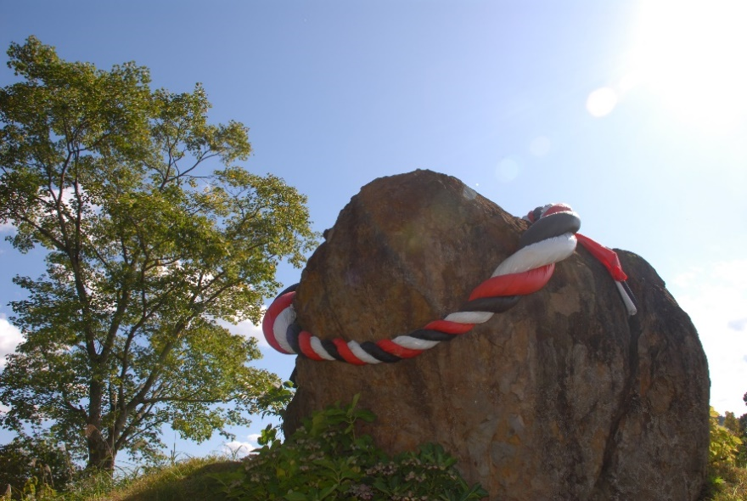
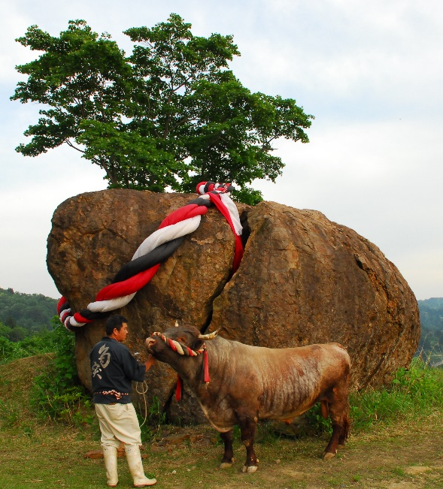
Mimamoriiwa

Mimamoriiwa is huge split rock with a knotted rope which is put on head of a bull when it enters bullring for a fight. It is located near the bullring in Higashiyama. The rock got split by the great Chūetsu earthquake happened on October 23rd, 2004. Back then all members of the bullfighting association cooperated together to protect bulls. The bullring and the district got great damage, but they restored it with the effort of local people and support from people all over Japan. The rock was so strong that it didn’t move even though it was split. Then people made the rock a symbol of recovery from the earthquake for its toughness putting a knotted rope on and named it Mimamoriiwa which means “a rock that watchs over us”.
It is a great photoshoot spot!

Address: Oguriyama, Ojiya

